Action Sheet for January 2016

CCL Monthly Conference Call, Saturday, Jan. 9, 2016
Groups meet at 9:45am PT/12:45pm ET
The international conference call starts at 10:00 am PT/1:00 pm ET
The conference call part of the meeting is just under an hour long, and groups meet for another hour after that to take and plan actions.
Call-in number: 1-866-642-1665, passcode: 440699#
Callers outside U.S. and Canada, please use Skype: 719-387-8317, passcode 440699#

Hahrie Han, Associate Professor, UC Santa Barbara

Our guest speaker at our January meeting is Hahrie Han. Han is the Anton Vonk Associate Professor of Environmental Politics in the Department of Political Science at the University of California, Santa Barbara. She specializes in the politics of environmental and social policy, focusing particularly on the role that civic associations play in mobilizing participation in politics and policy advocacy. Hahrie is also the author of the book, How Organizations Develop Activists.

Suggested Actions

- Celebrate your group’s 2015 successes.
- Start planning in-district meetings with members of Congress for the Spring Lobby Drive.

ACTION
Celebrate your group’s 2015 successes

The start of a new year is a good time to pause for a moment to look back on the previous year and acknowledge our achievements, to savor the victories and successes, big and small, that are already fading in our memories. At your meeting this month, review your group’s field reports from 2015 and celebrate those accomplishments – meetings with members of Congress or their staff, op-eds and letters to the editor published in your local newspaper, attending the conference in Washington, fundraising for CCL, regional conferences, outreach, expansion and so forth. As we prepare for an exciting and pivotal year of climate action, we need a big dose of inspiration. We can derive that inspiration, surprisingly, from ourselves and the people around us by celebrating our breakthroughs and achievements.

ACTION
Plan meetings for the Spring Lobby Drive

Back in November, we met with 172 congressional offices in Washington, thanks to the 140 volunteers who traveled to DC. As we’ve experienced in the past, these meetings with House and Senate offices are the highest leverage action we can take to move our legislation forward, and we’ve decided to make another push this spring. Instead of asking volunteers to come to Washington, though, we’re organizing a drive to do in-district meetings between March 24 and April 11. There are several advantages to this approach:

- We can target ALL congressional offices, not just members on key committees.
- More of our volunteers will be able to participate in the meetings.
- The chance of meeting face-to-face with members greatly improves, as they are not being called out of the office at the last minute for committee meetings.

At your meeting this month, begin the process of scheduling and planning meetings with senators and representatives. The addendum on the next two pages provides a step-by-step guide to the process.

Action addendum: CCL Spring In-District Lobby Drive

We‘re doing something new this year: holding our first ever in-district lobby drive this spring. What’s a lobby drive? It’s like a food drive but, instead of collecting food for the hungry, we are building political will for our cause. The goal is to hold 200 in-district congressional meetings with a member of Congress during the spring recess March 24-April 11. This calls for planning and teamwork! We will provide lots of training opportunities to support you. Here are the steps:

1) Determine who will set the appointment and where the meeting will be if the member of Congress has more than one office in the district or state. In many cases the designated liaison will make the request for an appointment. Liaisons will receive an email from the national office January 12th to verify who is making the appointment. Please respond by January 31st. If there is no liaison or the liaison is not going to request the appointment, AND your group is the only one in the district or state, then pick someone to be the appointment setter. If there is more than one CCL group in your district or state and the liaison is not requesting the appointment, then use your regional or state group leader call on January 19th to determine who will do it. Once the appointment setter has been determined, that person should go here to let us know at the national office. Good teamwork is important so that the scheduler for your member of Congress does not get conflicting requests from different people or groups. We will be provide training on how to request an appointment.

2) Start planning your meeting. Items to consider:

a. The suggested purpose for the meeting is to go over new research by Kevin Ummel that will detail for each congressional district what percentage of people receive more money from the dividend than they see in increased expenses from the carbon fee (and by how much). We will hold a training on this material (see below). Your group and the liaison should discuss other goals for the meeting based on your history with the member of Congress. We encourage you to end the in-district meeting with a request to meet with you and/or other CCL volunteers in DC for our Tuesday, June 21st Lobby Day.
b. In addition to requesting an in-district face-to-face meeting with your member of Congress this spring, you may want to request that other staff join the meeting. For example, the DC energy/environment aide could participate by Skype or conference call. The district director is an important staffer who has the member’s ear.
c. Discuss what office to approach to request the meeting if there is more than one office in the district/state. Ask yourselves: Is it best to meet at the office closest to you; to be open to any office; to pick the one your team can most easily reach; or to pick the one in the member’s hometown? In some cases, it may be appropriate to have meetings at more than one office.
d. Discuss who should be part of the lobby team. Considerations include the liaison, group leaders, representatives from different CCL groups or parts of the state/district, empowering new people, bringing along important influential supporters or endorsers as allies. Remember to ask ahead of time how many people they have room for in the office and keep your group size to no more than 6-7 people.

Remember to coordinate with other groups if yours is not the only group in the district/state. Teamwork matters!

3) Other considerations: Sometimes a drop-off of constituent mail (such as personal postcards, Valentines, or Constituent Comment forms) at the district office can be very helpful, so you might plan how to collect a lot of these in the next two months. Dropping them off in advance of the meeting can help encourage the scheduler to give you the meeting or have the member to drop by. Or perhaps there are endorsements you want to bring with you, or influential supporters such as a local elected official, farmer, faith leader, or business leader. Begin planning these supportive actions and work with other CCL groups that share your members of Congress.

4) Your regional or state group leader call on Tuesday, January 19th, will be an important place to ask questions, coordinate within the state for the Senators, and get ideas. If the group leader(s) can’t make the call, designate a substitute.

5) Suggested schedule

- Jan: Planning and preparation.
- Feb: The designated appointment setter requests the meeting and follows up as needed.
- March: Lobby team practices for the meeting. Don’t forget to file a field report afterwards!

6) What if you are offered a meeting before or after our Lobby Drive dates? Take it!! Having the meeting is much more important than all of us doing it at the same time. It won’t always be possible to get the meeting at the dates you request, but we will count all meetings in March and April as part of our spring in-district lobby Drive.

7) Lobby Drive training schedule:
Amy Bennett will go over how to schedule a meeting on the Jan. 25th liaison calls and the Feb. 2nd group leader calls. CCL University will offer the following webinars for all volunteers. Follow the links to RSVP for these sessions:
- 2/11: How to schedule a meeting with a member of Congress. Hosted by Amy Bennett.
- 3/10: In-district lobbying. Hosted by Jerry Hinkle and Danny Richter.
- 3/17: Spring Lobby Drive training. Hosted by Danny Richter and Mark Reynolds.

LASER TALK
Jobs gained with Carbon Fee and Dividend

According to a study from Regional Economic Models, Inc. (REMI), as a result of Carbon Fee and Dividend 2.1 million jobs would be added above the baseline after 10 years and 2.8 million after 20 years. The industries that see the most growth in jobs are health care and social assistance as well as the retail trade. This is because they are labor-intensive industries strongly affected by consumer spending. The dividend boosts consumer spending. The greatest losses occur in the mining (specifically coal) and utilities industries.

Increase in Jobs by Industry (national)

Notice from the graph that the combined losses in jobs suffered by the only four sectors that lose jobs are far outweighed by the increases in jobs in each of the top seven industries alone!
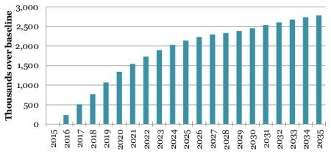
Increase in Total Employment (National)

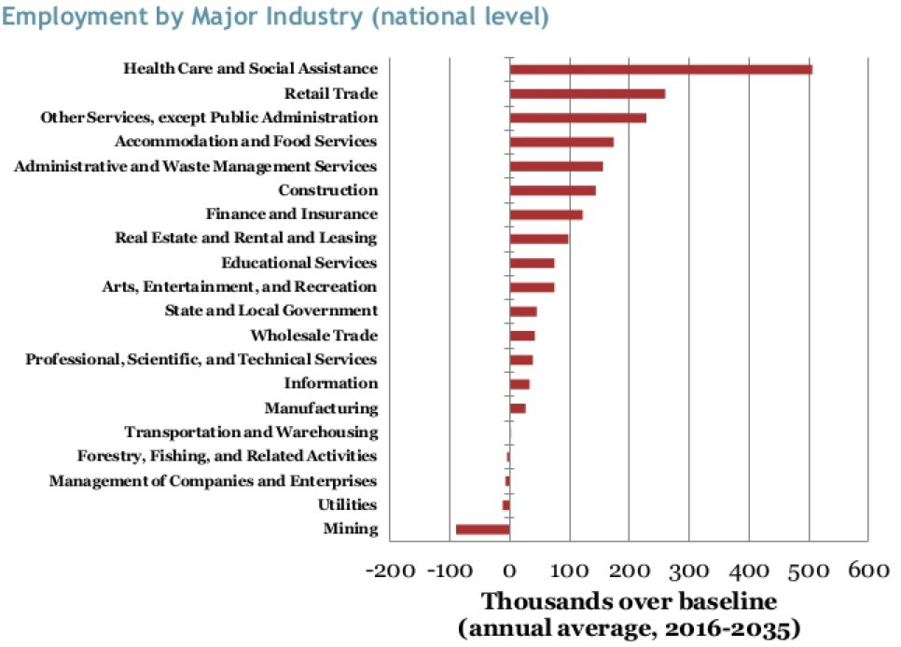

Increase in Total Employment by Industry (National)

